- You can Open embedded URLs in Iframe. Like :

<html:iframe width="420" height="315"src="https://www.youtube.com/embed/tgbNymZ7vqY">src="https://www.youtube.com/embed/tgbNymZ7vqY"></html:iframe>
- But If you still want to open the URL of google in Iframe, iFrames should be hosted on the same domain as the parent page.To do so follow below procedure.
- Open destinations of your HCP account and click on Add new Destination button.
- Configure this destination as below screenshot.
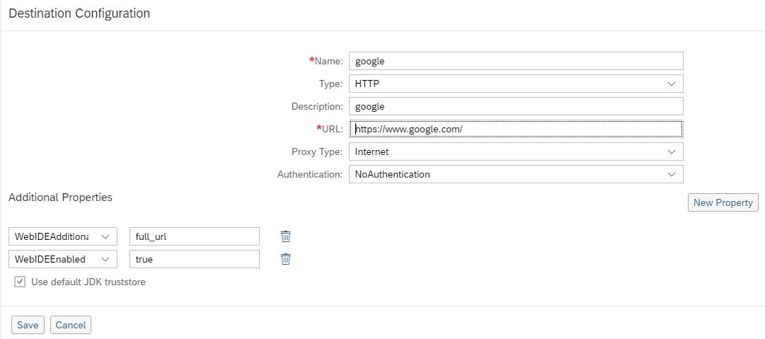
- Now Maintain this destination in neo-app.json file.
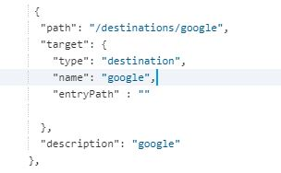
- Put below code in View to see website in Iframe.
<html:iframe src="/destinations/google" height ="400px" width="100%"> </html:iframe>

